User Manual

* First step
  + Go to the URL <https://smart-weather-playlist.web.app/musicapp> .
* Second step
  + If a window pops up to ask whether to allow the browser to know your location or not, you will click allow.
* Third step (Logging in)
  + Login with Gmail to create an account.
  + Gmail account is required to use the website.

* Fourth step (Home page)
  + After you logged in, you will be able to see this page which is the Home Page. In this page you will be able to see some functionality that the web app has.

* Fifth step (Apple Music - generate songs based on genres picked and search song.)
  + I will show you the Music page first where you can either search for music, pick a genre and generate music or generate music based on weather with Spotify.
  + This is how the page would look like.
  + To use Apple Music to generate music based on the genres you pick you would have to have an Apple Music account. If you have an account, then to proceed you will pick genres based on what you prefer and the genres you picked will show up on the right side where it says, “Genres selected”. After that there should be a window that will pop up.

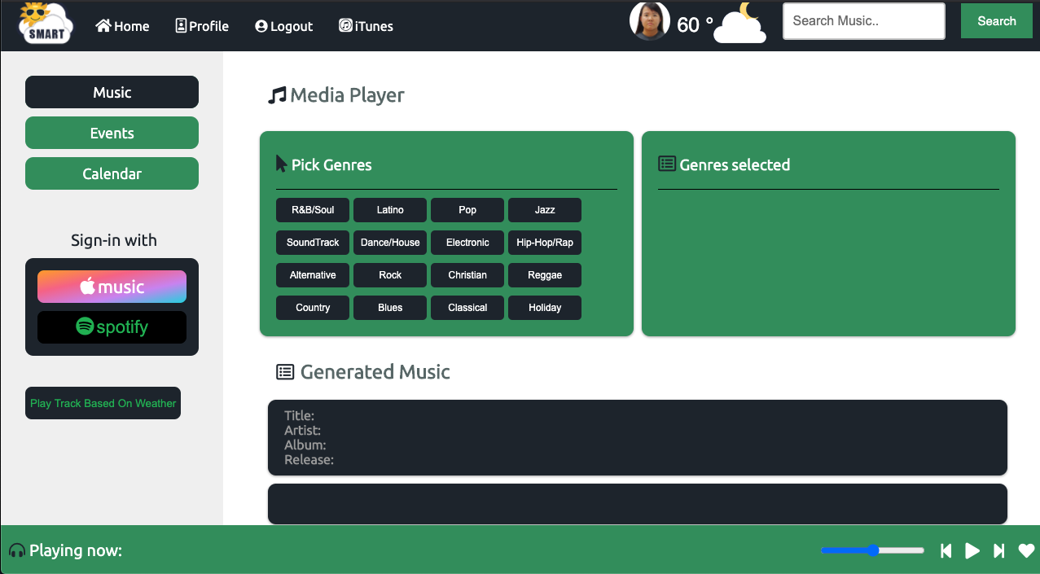

* + It will pop up a window for you to login.

* + Once you’ve logged in you will be able to see some album covers at the Generated Music section based on the genre that you picked. Like the screenshot below.

* + You will be able to play song by clicking on the album cover. The name of the song will show up in the media player below. As shown in the screenshot below.



* + On the top right of the page there is also a search bar where you can search for a song by the name of the song or artist.

* Sixth step (Spotify – generate music based on the weather.)
  + You can also use Spotify to generate music based on the weather.
  + On the left side you should be able to see a button that says Spotify when you click on that it will pop up a window and lets you login to Spotify with your account.

* + Once you have logged in, you can click on the button that says, “Play Track Based On Weather” which will be on the left side of the page.
  + After that you should be able to see the Spotify player below the button in the previous step. Just like the screenshot below.

* Seventh step (Creating events in the Events Page)
  + In this step you will be able to create an event by typing in Title, Start Time, End Time, Selecting the Date and Type of event. The page will look like the screenshot below.

* + You can change the month by clicking on the right arrow on the top of the small calendar display.
* Eighth step (Calendar Page)
  + Once you have created an event, you should be able to see it in the Calendar Page. You can go to that page by clicking on the button that says “Calendar” on the left side. You should be able to see the big calendar once you are in the page as shown below.

* + If you have events on a specific day you will see that the box of that day will be in yellow which means you have an event on the day. Just like the screenshot above.
  + You can change the month of the calendar by clicking on the right arrow above the big calendar display.
  + If you go further down the page you will see that there is an Event details of day section where you can pick a specific day, month and year where you have events on and see details of the events. Like in the screenshot below.

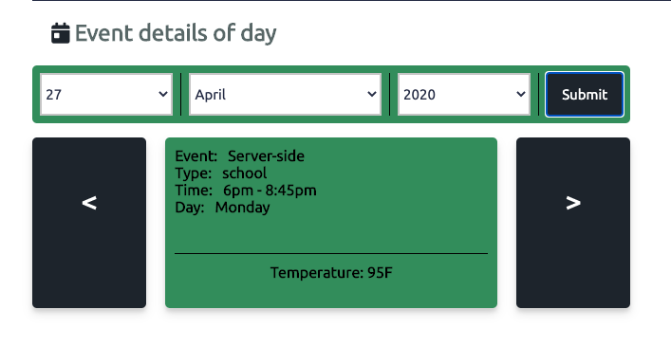

* + Another thing that would show your events on the specific day is when you click on one of the days where you have events on, and it will pop up a window just like in the screenshot below. It will show the type of event it is, the time and name of the event. If you want to delete the event you can just click on the red box with the white X.

* Ninth step (Profile Page)
  + If you would like to see your profile page, you can click on the button that says “Profile” on the Nav bar which is at the top of the web page.

* + You will be able to see your profile information in that page just like the screenshot below.

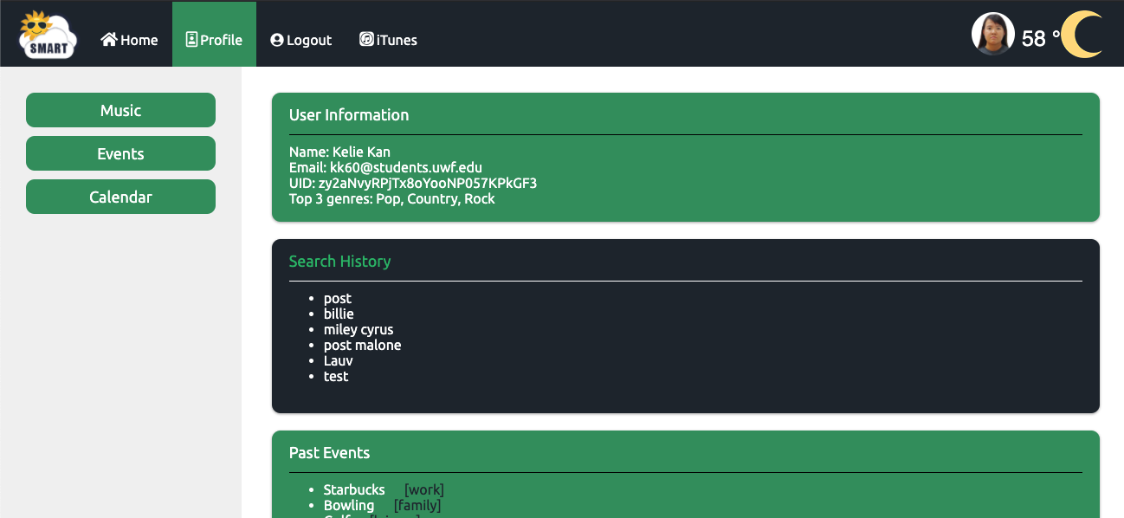

* Tenth step (Weather and Logout)
  + On the nav bar which is at the top of the page you will be able to see a weather icon with the temperature displayed that is based on the weather at your location. Which is shown in the screenshot below.

* + To log out of the website you will have to click on the button on the nav bar at the top of the page where it says “Logout”.

* + It will take you to the logout page and you would just have to click on the logout button on the left side of the page and you will be logged out.

